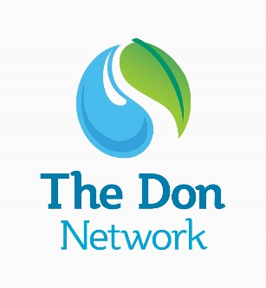
Catchment Plan Review Questionnaire
Thank you for helping to review the Don Network Catchment Plan. The Don Network was one of 25 pilot catchment partnerships, and the original plan was published in 2012 after 18 months of consultation with groups and organisations working in the catchment.
Lots has been achieved in the catchment since then, and we want to review the plan to celebrate those successes, but to also highlight priorities for work still to be done.
On 26th November 2019 we held a plan review workshop. Below are the questions we asked of attendees, and we would be very grateful if you could also contribute to the review by giving us your thoughts.
The survey will be open for responses until Monday 6th January 2020, and you can click here to download a copy of the original plan. Please send your responses to donnetwork@dcrt.org.uk.
Thank you,
The Don Network

Question 1:
Is the original vision of the network still relevant?
The original vision of the catchment plan is:
- Water quality that supports a natural ecosystem and public use and enjoyment
- Collaborative flow management – balancing ecology with the needs of catchment users
- A more natural habitat – through the removal of invasive species and sensitive management of ecological networks, with self-sustaining fish populations including migratory salmon and trout
- Best agricultural practice – to manage land to prevent water pollution
Let us know your thoughts and comments:

Question 2:
What have we achieved against the original ‘opportunities’ in the catchment plan since it was published in 2012?
Please note the achievements against the following opportunities that you or your organisation have made:
- Land management

- Morphology

- Maintenance of river channels

- Habitats and species

- Water Quality

- Sustainable Urban Drainage Systems (SUDS)

- Reservoirs Management

- Data and information

- Communications and engagement

Question 3:
Are the original opportunities still relevant? Are there any missing?
Suggestions have included: natural flood management; adapting to climate change; educating the public; working with communities

Question 4:
What is planned?
Can you tell us about upcoming projects and initiatives in the catchment that we could highlight in the catchment plan?

Question 5:
As a network: what are the barriers to our success? Are there any problems that need addressing? What are the key challenges in the catchment?

Question 6:

What are our particular strengths in the catchment?

Question 7:
Thinking about the original opportunities, and any new ones you have identified:

Are there any new partners needed in the Don Network?

Question 8:
Is there anything that could improve communications in the network?
For example: Could we organise themed forums to share knowledge? Do we need to meet more regularly than the annual Don Network Day? Do we need a steering group?

Question 9:
Does the name ‘Don Network’ work for our catchment partnership?
It has been noted that the name ‘Don Network’ is not inclusive of the Rother and Dearne. What are your thoughts on this? Could the name of the catchment partnership be improved?

Question 10:
Tell us about your own organisation’s strategies and action plans that direct your activities …

To ensure we are getting a representative set of responses, please could you tell us:
Your organisation:
Your department within the organisation (if relevant):

If you would like to join the Don Network mailing list, please provide your name and email address:

Thank you very much for your answers. After the survey closes we will be collating responses with those from the workshop, and pulling together a first draft of the catchment plan review.

