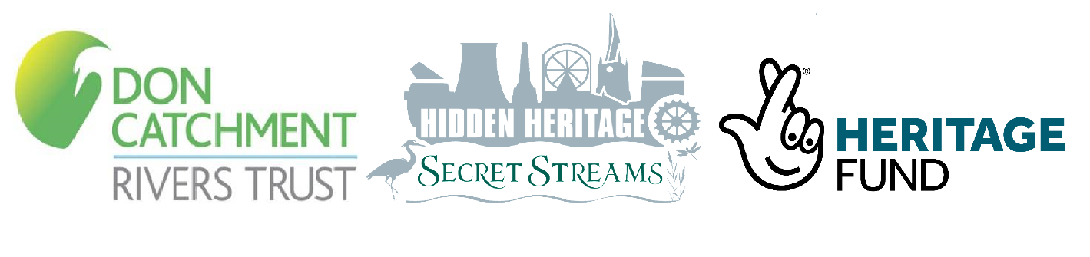DCRT Well dressing kits 2020 – Request a Kit
Well dressing is an ancient calendar custom in Derbyshire, first documented in Chesterfield in 1864 when the town decorated the market place water pump during a very dry summer. Like many of the UK's calendar customs, the tradition died out but was revived in 1991 and has continued ever since. The dressings are created on boards of clay, carefully decorated with natural materials such as petals, eggs shells, seeds and leaves.

This year DCRT hope to make their first well dressing to celebrate our rivers and everything they provide us.
Due to the coronavirus pandemic, DCRT will be hosting a socially-distanced well dressing construction, by giving out free mini well dressing kits to residents of Chesterfield. The kits will include a board, clay and other materials (you can collect your own decorative materials too!) as well as instructions on how to create your masterpiece!

Key Dates:
Kits will be dropped off to your address on Monday 7th September.
Participants will need to complete their well dressing in the week of the 7th-11th September, for collection on the morning of the 11th September.
The individual dressings will then be assembled and displayed together at Tapton Lock Activity Centre from the 12th-18th September.
If you would like to take part please fill in the form below and return it to info@dcrt.org.uk by the 7th August 2020.
Name(s)
Chesterfield address for drop off and collection of kits
Details of safe place if you’re not in?
Phone Number for contact
Have you taken part in well dressing before?

